**@root.dns**

# vim /etc/bind/named.conf

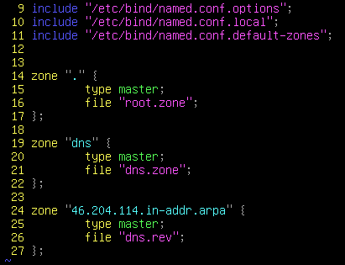

# vim /etc/bind/named.conf.options //forward 설정이 되어있으면 안됨.

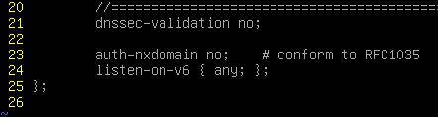

# vim /var/cache/bind/root.zone

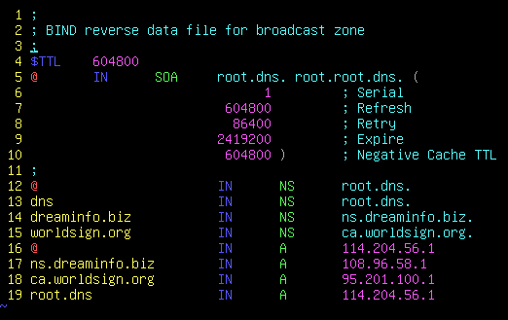

# vim /var/cache/bind/dns.zone

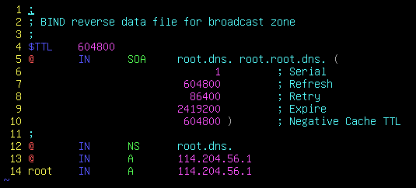

# vim /var/cache/bind/dns.rev

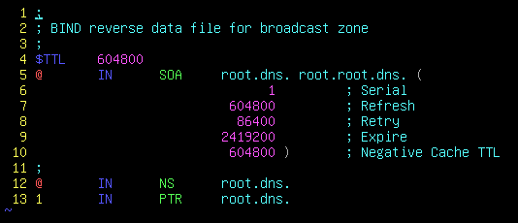

# vim /etc/bind/named.

**@ca.worldsign.org DNS**

# vim /etc/bind/named.conf.default-zones // 주석처리

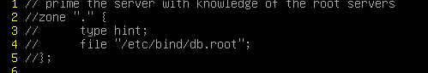

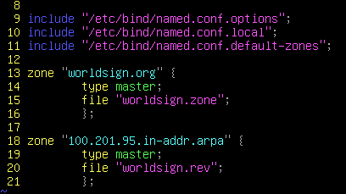

# vim /etc/bind/named.conf.options

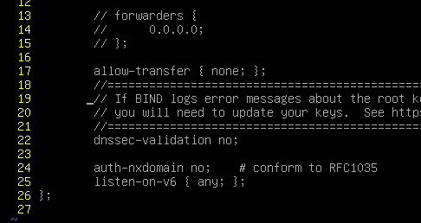

# vim /var/cache/bind/worldsign.zone

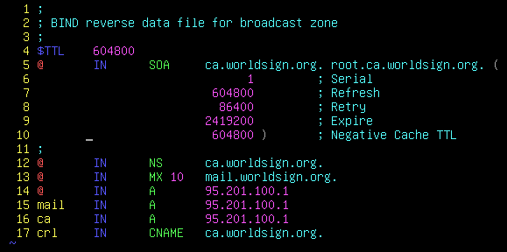

# vim /var/cache/bind/worldsign.rev

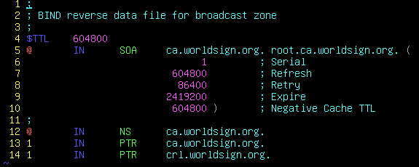

# vim /etc/bind/db.root



**@ns.dreaminfo.biz**

# vim /etc/bind/named.conf





# vim /etc/bind/named.conf.options

// 10.8.0.0/24 는 Openvpn 대역



# vim /etc/bind/db.root



# vim /var/cache/bind/dreaminfo.int.rev1



# vim /var/cache/bind/dreaminfo.int.rev2



# vim /var/cache/bind/dreaminfo.int.zone

